**Random Variable:**

Variable whose value is determined by a random experiment.

**Discrete probability distribution:**

Table or Formula that lists the probabilities for each outcome of the random variable, X

**Flip 3 coins at same time.**

Let random variable X be heads showing

Discrete probability distribution

HHH 3 heads

HHT 2 heads

HTH 2 heads

HTT 1 heads

THH 2 heads

THT 1 heads

TTH 1 heads

TTT 0 heads

|  |  |  |  |  |
| --- | --- | --- | --- | --- |
| x | 0 | 1 | 2 | 3 |
| P(X=x) | 1/8 | 3/8 | 3/8 | 1/8 |

P(X = 0) = 1/8

P(X = 1) = 3/8

P(X = 2) = 3/8

P(X = 3) = 1/8

1/8 + 3/8 + 3/8 + 1/8

Binomial formula

 

Toss the coin

n =3

K = 2

P = .5

3x2x1 / 2x1x1 (0.52 x 0.51)

= 6/2(0.5x0.5x0.5)

= 3(0.125)

=0.375

**Poisson Distribution**

A Poisson distribution is the probability distribution that results from a Poisson experiment.

A Poisson experiment is a statistical experiment that has the following properties:

* The experiment results in outcomes that can be classified as successes or failures.
* The average number of successes (μ) that occurs in a specified region is known.
* The probability that a success will occur is proportional to the size of the region.
* The probability that a success will occur in an extremely small region is virtually zero.

Note that the specified region could take many forms. For instance, it could be a length, an area, a volume, a period of time, etc.

==> Supermarket Q between 4:30 to 4:45

==> Average customers are 10

==> What is the probability of exactly 7 customers enter your line between 4:30 to 4:45?

What is the probability of more than 10 customers enter your line between 4:30 to 4:45?

The outcome can be by

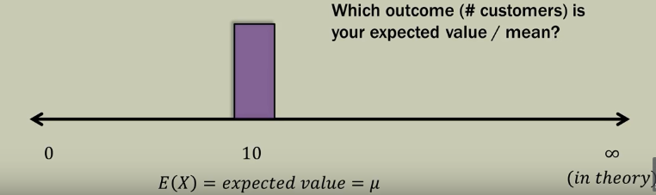

**Poisson formula**

P(*x*) = (e-μ) (μx) / x!

* e: A constant equal to approximately 2.71828. (Actually, e is the base of the natural logarithm system.)
* μ: The mean number of successes that occur in a specified region.
* x: The actual number of successes that occur in a specified region.

Q1 - What is the probability of exactly 7 customers enter your line between 4:30 to 4:45?

X = 7

μ = 10

e = 2.1718282

P(7) = (2.1718282-10) (107) / 7!

= 0.09

Q1 - What is the probability of more than 10 customers enter your line between 4:30 to 4:45?

Get the total value of probability 0 to 10

1 – the above value is the probability of above 10 customers

**Negative Binomial Experiment**

The negative binomial experiment is almost the same as a binomial experiment with one difference: a binomial experiment has a fixed number of trials.

The negative binomial is similar to the binomial with two differences

* The number of trials, n is not fixed.
* A [random variable](http://www.statisticshowto.com/random-variable/) Y= the number of trials needed to make r successes.

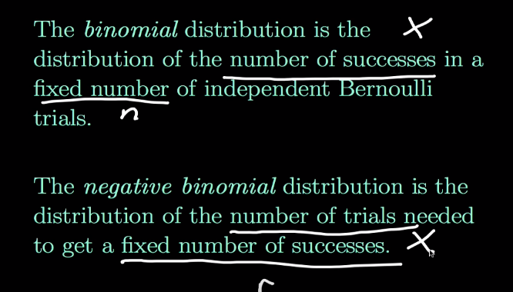

b*(*x*; *r, P*) = x-1Cr-1 * Pr * (1 - P)x - r

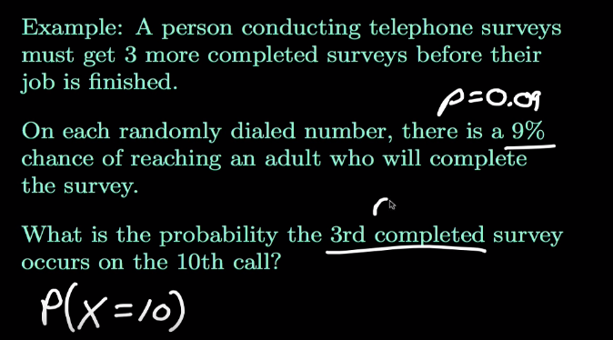

**The Mean of the Negative Binomial Distribution**

If we define the mean of the negative binomial distribution as the average number of trials required to produce r successes, then the mean is equal to:

μ = r / P

where μ is the mean number of trials, r is the number of successes, and P is the probability of a success on any given trial.

Geometric Distribution



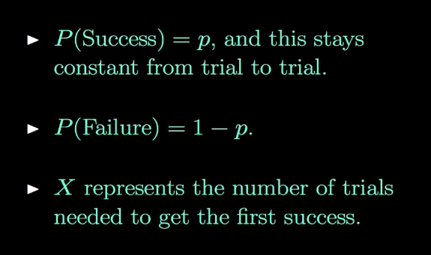

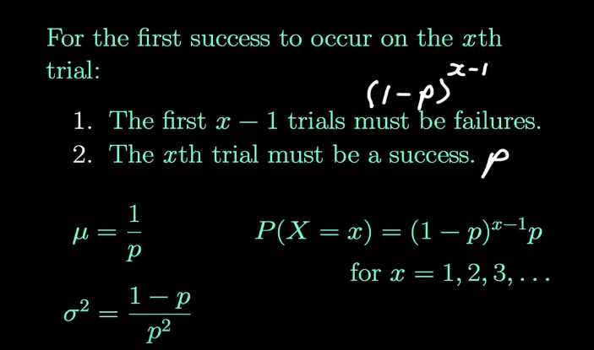

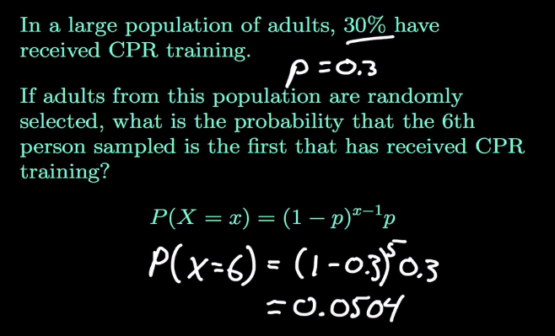

Hypothesis

A claim that we want to test

Null Hypothesis – H0 – Currently accepted value for a person

Alternative Hypothesis – Ha – Also a research hyp. Involves that the claim to be tested.

Hypotheis testing

Possible outcomes of this test

* Reject H0
* Accept H0

Test statistic

Calculate from the sample data

Ex – sample 50 bars

Get avg value

Calculate test statistic

Statistically significant – Where do we draw the line to make a decision?

Level of confidence

C - 95%...99%

Level of significance

Alpha = 1-C